**Assignment -1**

Digital Marketing

|  |  |
| --- | --- |
| Student Name | Jothi Anantha Kumar D |
| Student Roll Number | 20URCS018 |
| NM ID | 9EEA217E4294145B2C0498F030D9E2DC |
| College Name | AAA College of Engineering and Technology |

**QUESTION:**

**Create a blog or website using Blogspot and WordPress. Customize the theme design and post new article with 500 words.**

**BLOG USING BLOGSPOT:**

**Blog link:** <https://lathemachine727.blogspot.com/2023/10/cnc-lathe-machine.html>

**Blog Title:** CNC LATHE MACHNE

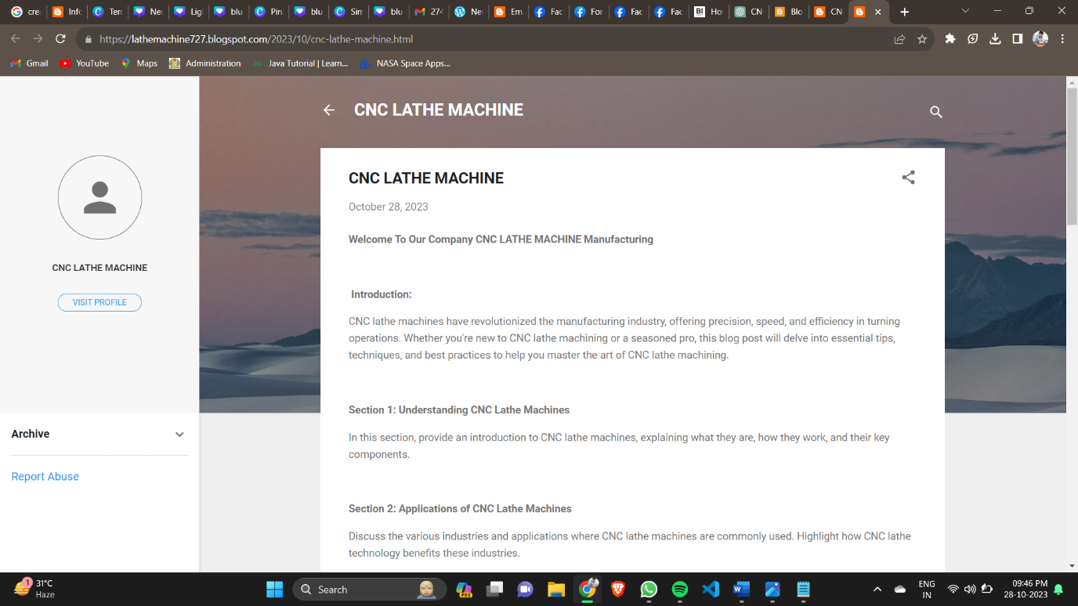

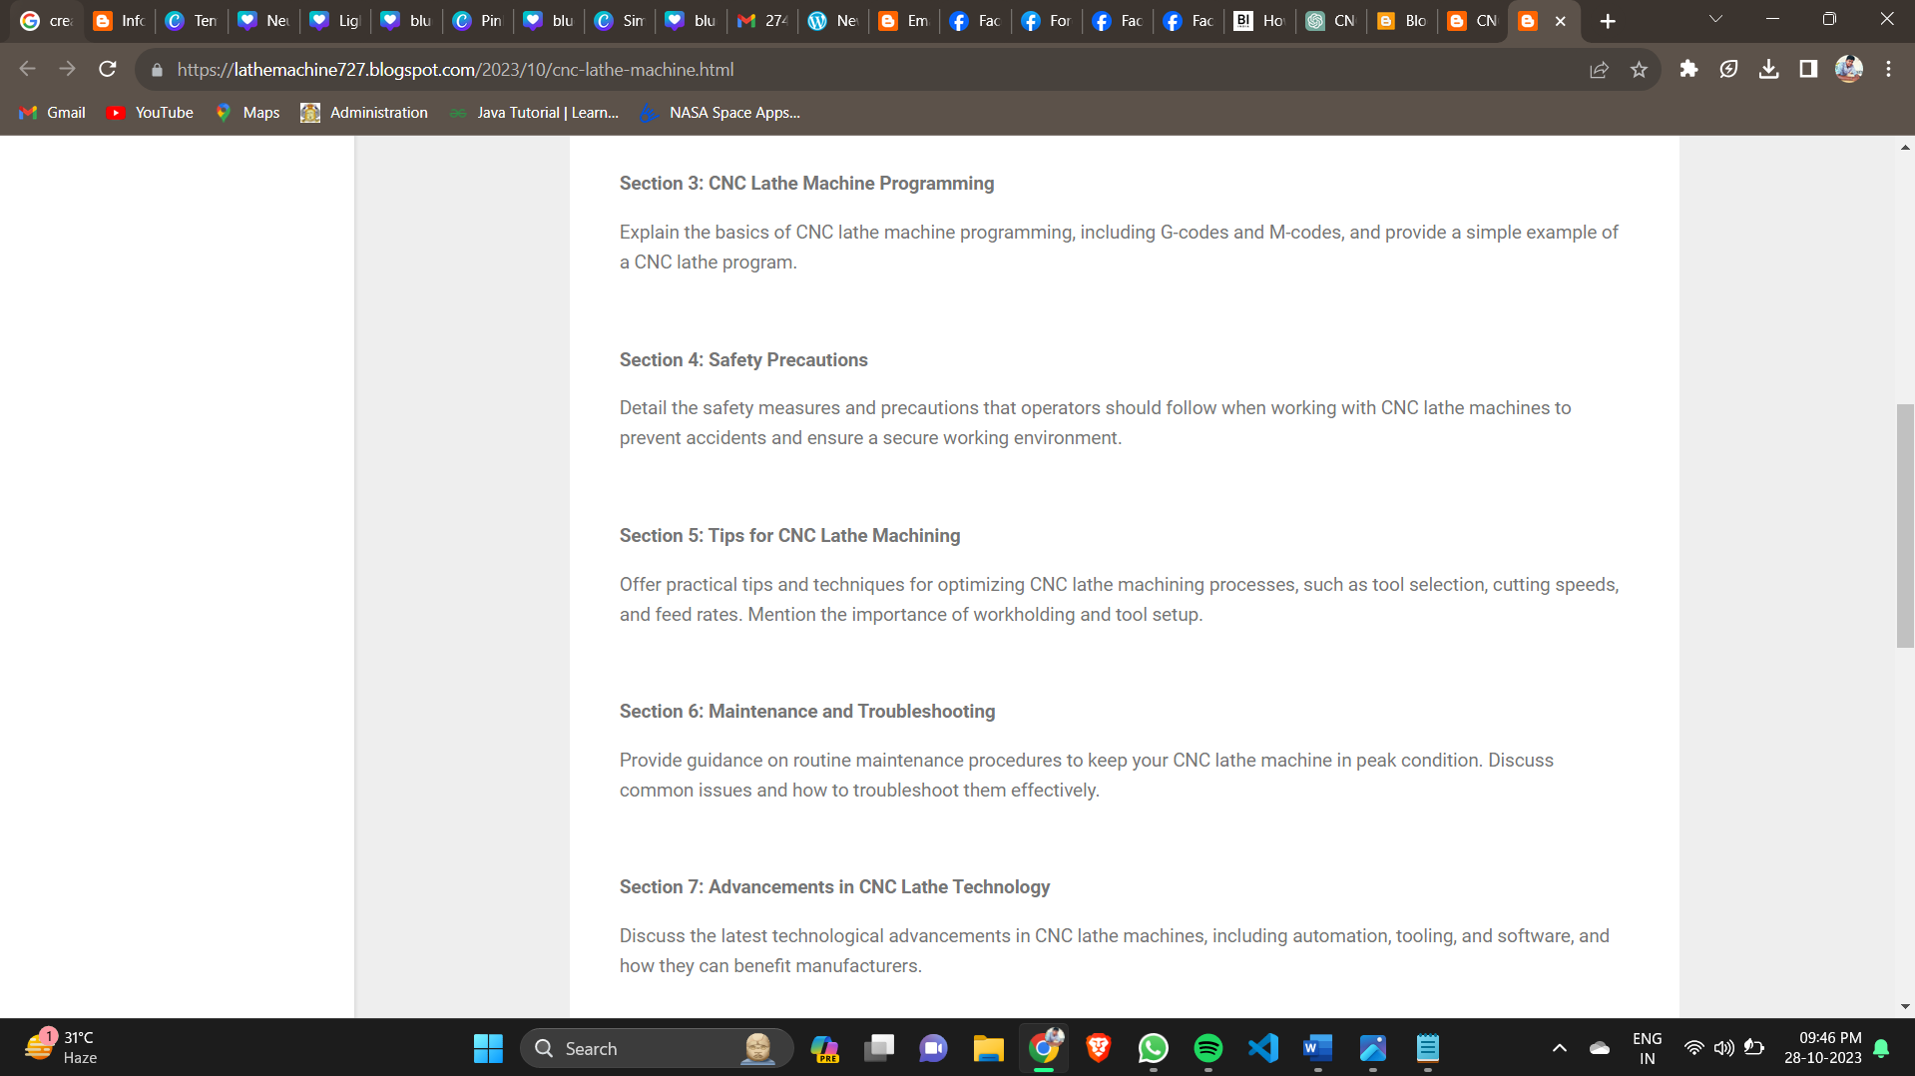

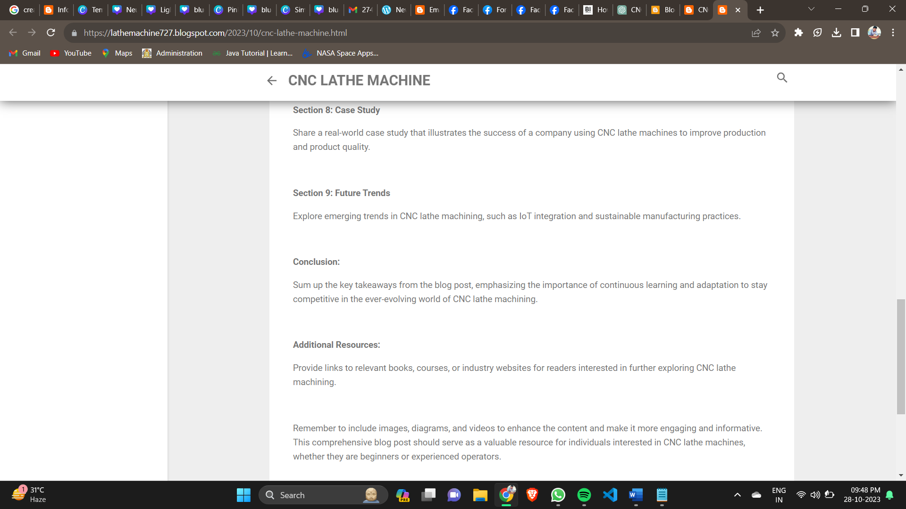

**BLOG USING WORDPRESS:**

**Wordpress link:** <https://ananthstarck5151.wordpress.com/>

**Blog Title: CNC LATHE MACHINE**

